Prompt:
I have attached an SRS document. Based on the requirements, generate manual test cases. Each test case should include: Test Case ID, Description, Steps, Expected Result. Keep it simple and concise.
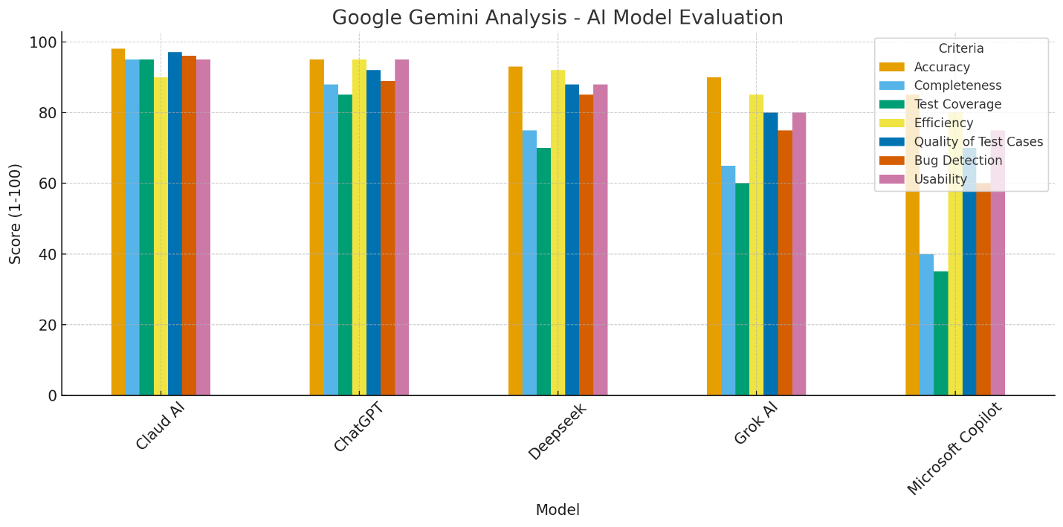
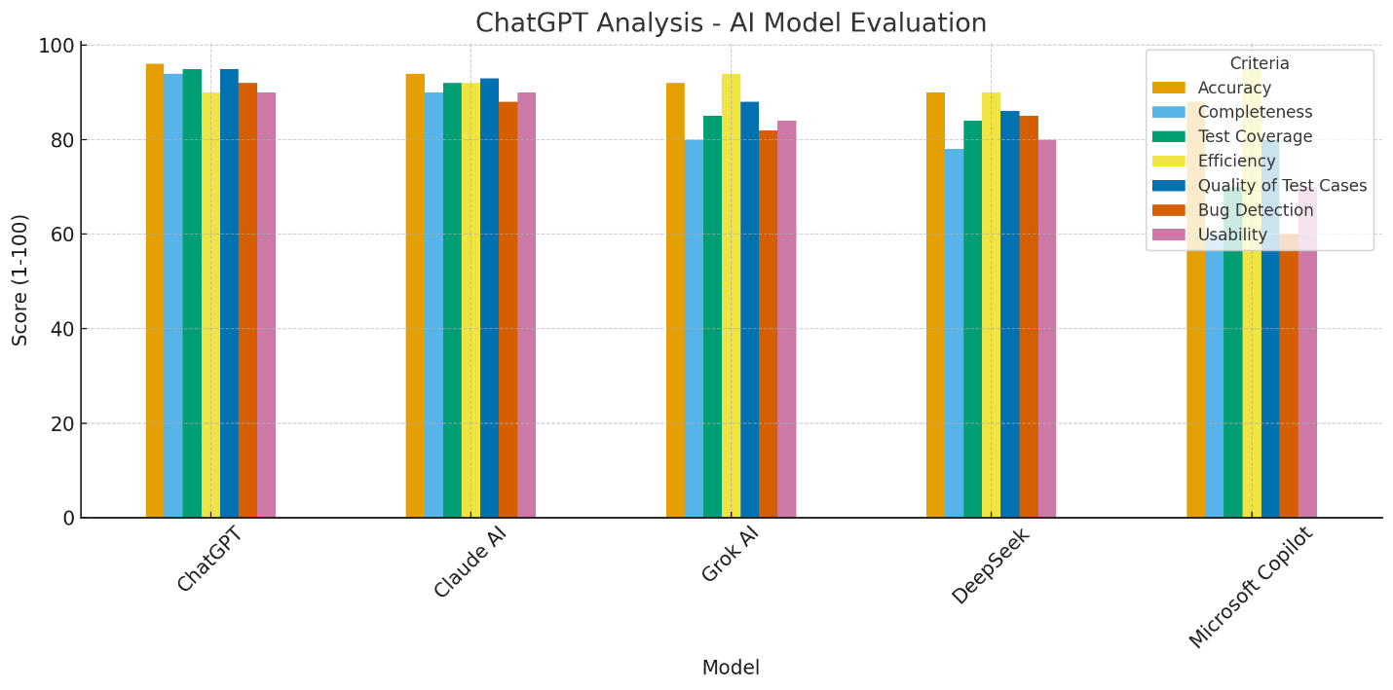

Manual Analysis
Based on the manual analysis, ChatGPT emerged as the best performer, followed by Claude in terms of coverage. ChatGPT provided a smart presentation, well-structured test cases, and broader coverage. As usual, DeepSeek and Grok were the weakest performers.

